Multiple-choice section – choose the correct answer

Question 1 [8.3]

For the polynomial P(x) = x3 – x2 – 4, the value of P(-2) is:

A 4 B -16 C 1 D 16

Question 2 [8.2]

The graph of y = x2 is transformed to y = 6 – 3x2 by:

A a translation of 3 units up and 6 units left

B a translation of 6 units up and 3 units left

C a reflection in the x-axis, a dilation by a factor 4 in the y-direction, a translation of 6 units down

D a reflection in the x-axis, a dilation by a factor 3 in the y-direction, a translation of 6 units up

Question 3 [8.3]

State the degree, leading coefficient and constant term (in that order) for the polynomial:  
P(x) = x2 – 2x4 + 7

A 4, -2, 7 B 7, 4, 2 C 7, -2, 4 D 2, 1, 7

Question 4 [8.3]

The remainder when x3 – x2 + 3x + 2 is divided by (x – 1) is:

A 2 B -3 C -1 D 5

Question 5 [8.5]

The y-coordinate of the y-intercept for y = 2x3 + 5x2 – x + 6 is:

A 5 B -2 C 6 D -6

Question 6 [8.2]

If the graph of the equation y = x3 is transformed by dilating it by a factor of 5 in the y-direction, and then translating the graph 2 units to the right and 1 units down, the equation of the new graph is:

A y = 5(x + 2)3 – 1 B y = 5(x – 2)3 – 1 C y = 5 – 3(x + 2)3 D y = (x – 2)3 + 5

Multiple-choice results: ___ / 6

Short answer section

Question 7 3 marks [8.1, 8.3]

From the list of words below, choose the correct word to complete the following sentences:

cubic degree leading term non-monic quotient remainder quartic

(a) The ______________ of a polynomial is the value of the highest power in the polynomial.

(b) The equation y = 3x2 – 4x + 1 is a ___________________ quadratic equation.

(c) In a polynomial, the term with the highest power is called the ___________________.

Question 8 2 marks [8.2]

Explain the different ways in which a graph can be reflected.

Question 9 4 marks [8.2]

(a) Plot the following points on the set of axes provided:

(i) A(3, 1) (ii) B(-4, -3)

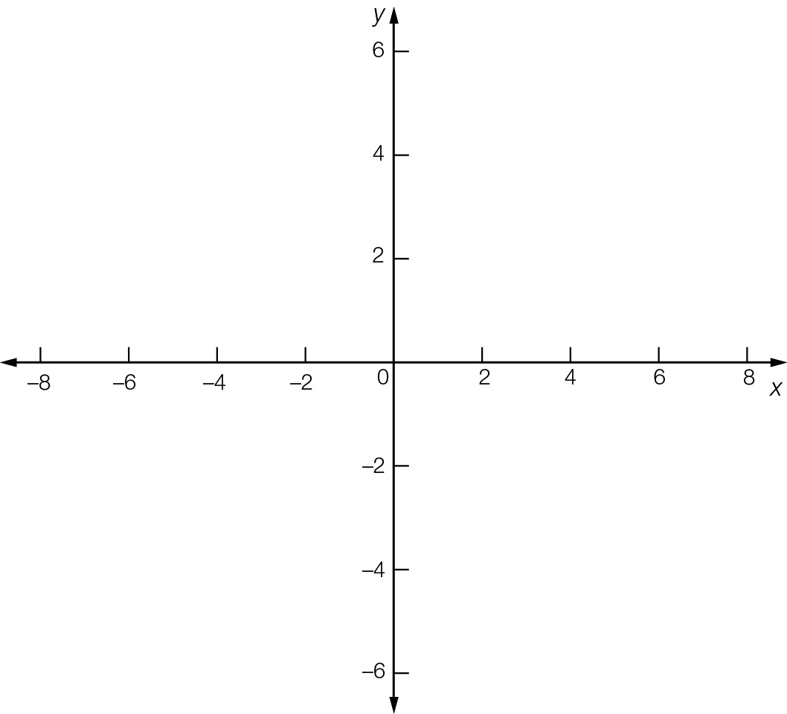

(b) State the coordinates of each point after it is:

(i) translated 2 units right:

A(i) = B(i) =

(ii) reflected in the y-axis

A(ii) = B(ii) =

(iii) dilated by a factor of 3 from the x-axis.

A(iii) = B(iii) =

(c) Plot each point in (b) on the same set of axes as (a).

Question 10 8 marks [8.2]

(a) Sketch the line with equation y = x – 1, on the set of axes below, showing the intercepts with the axes.



(b) State the equation of the line y = x – 1, after it has undergone each of the following transformations.

(i) translated up 3 units

(ii) translated right 1 unit

(iii) reflected in the y-axis

(iv) reflected in the x-axis

(c) Sketch the resulting lines on the same set of axes as (a) and label them clearly.

Question 11 8 marks [8.2]

(a) For the graph of y = (x – 2)2 – 4, determine the coordinates of the:

(i) turning point

(ii) y-intercept

(iii) the x-intercepts

(b) Sketch the graph of y = (x – 2)2 – 4 on the axes provided, clearly labelling the turning point and the axes intercepts.

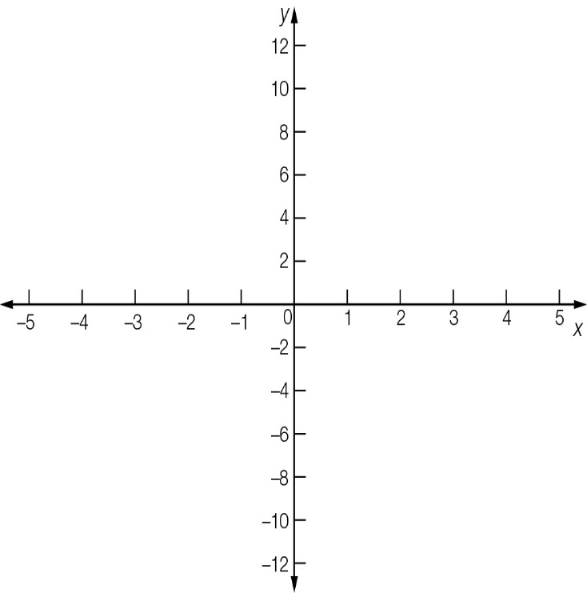

(c) State the equation of the graph after it has undergone each of the following transformations. Sketch the resulting parabolas on the same set of axes and label them clearly.

(i) translated 4 units to the left

(ii) dilated by a factor of 2 from the x-axis.

Question 12 3 marks [8.2]

Sketch the graph of y = (x + 1)3 + 2.

Label the coordinates of the point on the graph where x = -2.

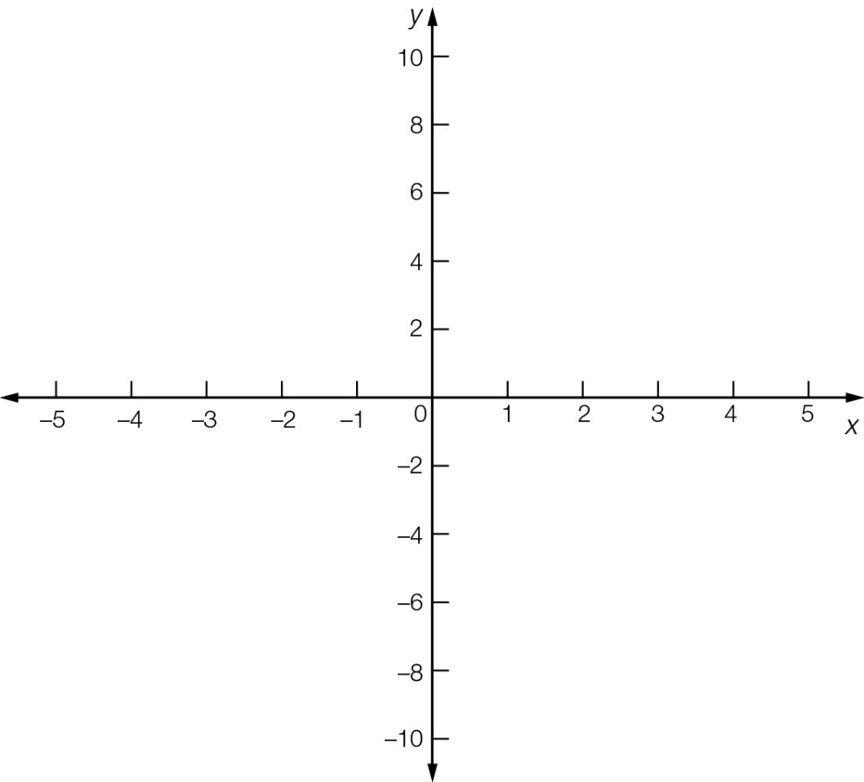

Question 13 4 marks [8.2]

State the transformations required to produce each of the following graphs from the graph of y = x2.

(a) y = (x + 2)2 – 1

(b) y = -2(x + 3)2

Question 14 4 marks [8.5]

A parabola of the form y = ax2 + bx + c has x-intercepts of (-2, 0) and (1, 0) and a y-intercept of  
(0, -4). Find the values of a, b, c.

Question 15 2 marks [8.4]

Show that x + 1 is a factor of 5x2 + 7x + 2.

Question 16 2 marks [8.3]

Write a non-monic polynomial that has four terms, degree 5 and a negative leading term.

Question 17 4 marks [8.3, 8.4]

(a) Use long division and the factor theorem to factorise x3 – x2 – 4x + 4.

(b) Hence solve x3 – x2 – 4x + 4.

Question 18 4 marks [8.3]

Write 2a(x) × b(x) − c(x) in simplest form if a(x) = 2x – 1, b(x) = 1 – x2 and c(x) = 3x2 + 4x – 2.

Question 19 2 marks [8.3]

Find a non-monic polynomial P(x) of degree 3 so that P(x) ÷ (x – 4) leaves no remainder.

Question 20 2 marks [8.3]

Find the value of k if (x – 4) is a factor of 2x2 – kx + 16.

Short answer results: ___ / 52

Extended answer section

Question 21 5 marks [8.2]

The shape of the lower edge of the arch of a small bridge is a parabola whose equation is given by  
y = 5 – 0.2(x – 8)2, where x is the horizontal distance (m) from a point on the ground to the left of the bridge and y represents the height (m) of the bridge above the ground.  
The upper edge of the arch has the same shape as the lower edge but is 4 m above it.

(a) What is the equation that describes the shape of the upper edge of the arch?

(b) Find values of x (to 1 decimal place) between which the upper edge spans.

(c) What is the maximum height of the arch of the upper level above the ground?

Question 22 6 marks [8.5]

A figure skater skates across a rink. The path can be described by the equation  
y = 0.01(x3 – 23x2 + 90x), where x represents the horizontal distance from the starting point  
 and y is the distance moved sideways away from the direct path.  
(The x-axis joins the start and finish points.)

(a) Sketch the path the skater followed.

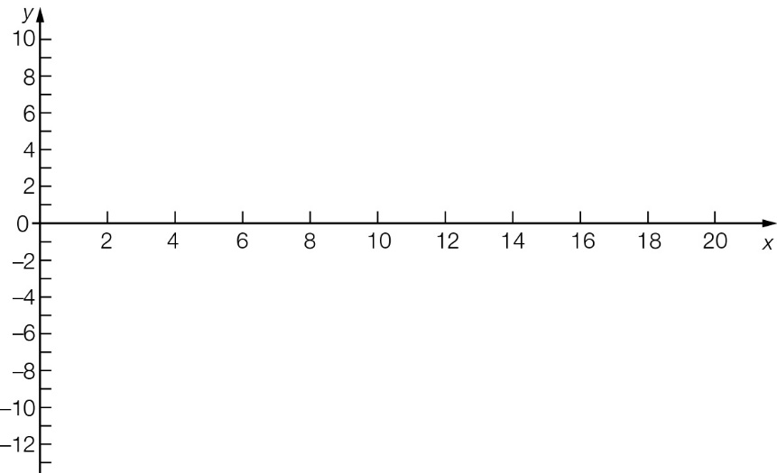

(b) Find the three distances from the start at which the skater crosses the direct path across the rink.

(c) How far is it across the rink?

Question 23 5 marks [8.5]

The cross-section of a mixing bowl can be described by the equations, where w and d are measured in centimetres.

d = (w − 6)2 for 0 ≤ w ≤ 6

d = 0 for 6 < w < 15

d =  (w − 15)2 for 15 ≤ w ≤ 21

(a) Sketch the three curves on the axes below to show the cross-section of the bowl.

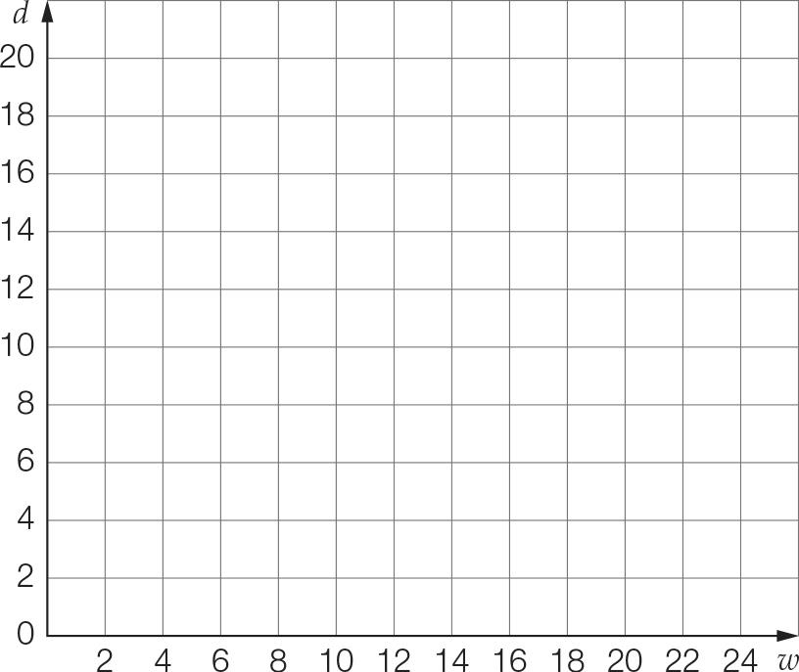

(b) What is the diameter of the rim of the bowl?

(c) Calculate the depth of the bowl.

Extended answer results: ___ / 16

TOTAL test results: ___ / 74